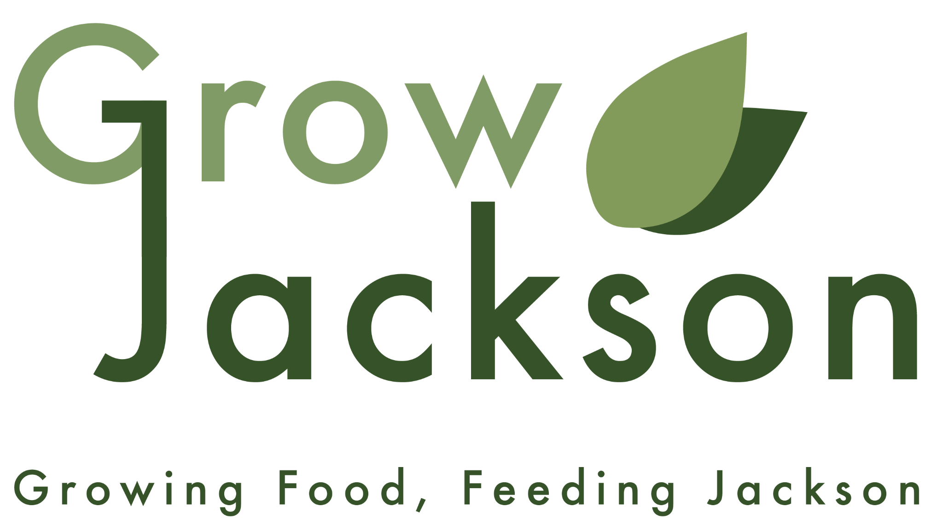

Farm Stop Manager
Organization: Grow Jackson
Location: Jackson, MI
Schedule: 40 hours per week in person
Compensation: $20 - $25 / hr (Pay increase available for bilingual Spanish)

Position Overview
Grow Jackson is seeking three (3) Managers to lead the daily operations of the River & Rail Farm Stop, a mission-driven, locally-sourced neighborhood grocery and café. The positions are General Manager, Grocery Manager, and Café Manager. These are exciting opportunities to join Grow Jackson as founding members of the Farm Stop team.
These roles blend retail management, local food sales, and community-centered customer service. Managers will oversee store operations to ensure the Farm Stop remains welcoming, efficient, and aligned with Grow Jackson’s mission to prioritize fresh food access. These positions are ideal for someone who loves food, thrives in a hands-on leadership role, and wants to build local food infrastructure in Jackson.

Key Responsibilities: General, Produce, and Café Managers (80%)
About 80% of the key responsibilities will be the same for all three managers.
- Work alongside staff, customers, farmers, and partners to oversee the day-to-day operations of the Farm Stop and Café, including opening, closing, and ensuring smooth daily operations.
- Hire, onboard, supervise, coach, and support staff and volunteers.
- Model exceptional customer service, fostering a welcoming environment and resolving customer concerns promptly and compassionately.
- Manage inventory, ordering, product displays, and restocking to ensure products are well-presented, available, and aligned with customer demand.
- Coordinate deliveries and maintain strong relationships with farmers and producers, including inventory planning, product feedback, and resolution of producer concerns.
- Ensure store cleanliness, organization, food safety compliance, and adherence to operational policies and procedures.
- Oversee point-of-sale systems, cash handling, sales transactions, and routine operational reporting.
- Maintain accurate records related to deliveries, sales, inventory, and waste, and prepare reports for management and producers as needed.
- Monitor, troubleshoot, and coordinate maintenance of store, café, and operational equipment to ensure safe and efficient operations.
- Contribute to continuous improvement of systems, processes, and overall Farm Stop performance.
- Other job duties as assigned

General Manager: Key Responsibilities (20%)
The General Manager will also complete basic administrative tasks, coordinate with other Grow Jackson programs and initiatives, facilitate resolution to team concerns, and support the other two managers in their key responsibilities as needed.

Grocery Manager: Key Responsibilities (20%)
The Grocery Manager will be the resident food “expert,” taking the lead on producer recruitment and relationships and customer education around specific products and producers. The Grocery Manager will support the other two managers in their key responsibilities as needed.

Café Manager: Key Responsibilities (20%)
The Café Manager will train employees to prepare drinks and use café equipment, monitor stock of café supplies to place timely orders, and develop and update the café menu based on seasonality and sales. The Café Manager will support the other two managers in their key responsibilities as needed.

Required Experience
The successful candidate must be able to perform all key responsibilities of their position. There is no formal education requirement. Additionally, a qualified applicant will have experience in at least one of the following areas:
- Retail and/or Sales
- Food systems (farming, grocery store, cafe, restaurant)
- Customer service, preferably in a food or hospitality setting

Beneficial Experience
- Experience managing or supervising staff
- Bartending, barista, serving, or other hospitality experience
- Experience in education, nonprofit, or social services
- Bilingual Spanish/English (salary increase available)

Qualifications & Values
A successful candidate:
- Loves food and believes in supporting local farmers and producers
- Center customer and farmer experience, center
- Embraces a team culture centered on community, dignity, and access
- Is reliable, organized, and adaptable
- Is comfortable balancing multiple demands in a fast-paced, community-facing environment
- Models participatory leadership, effective communication, and accountability
- Maintains a calm demeanor under challenging circumstances
- Values both sharing and receiving knowledge from others
- Asks questions and welcomes questions from others
- Is comfortable making decisions that drive day-to-day operations of the Farm Stop and Café

Why Work at Grow Jackson
This role offers the opportunity to help launch and lead a community-owned food space that blends grocery, café, and local food systems. The Farm Stop is more than a store, it is a cornerstone of Grow Jackson’s broader food access and food hub work.
Working Conditions & Physical Demands
- Work is performed in a variety of environments including offices, retail spaces, farms and gardens, classrooms, community centers, event venues, kitchens, warehouses, and outdoor settings.
- Responsibilities may vary significantly based on organizational priorities, community needs, seasonal demands, funding opportunities, and emerging initiatives.
- Employees should expect a wide range of duties and projects that may evolve as Grow Jackson and the River & Rail Food Hub continue to grow and adapt to community needs.
- Evening, weekend, and occasional holiday work may be required to support programs, events, markets, meetings, and community activities.
- Must be comfortable working independently and collaboratively in a fast-paced, mission-driven environment with changing priorities.
- Regularly required to stand, walk, bend, kneel, squat, reach, and perform repetitive motions for prolonged periods of time.
- Ability to lift, carry, push, and pull materials, supplies, equipment, and products weighing up to 50 pounds.
- Ability to work indoors and outdoors in varying weather conditions, including heat, cold, rain, dust, and humidity.
- Ability to safely operate or utilize common office, retail, garden, kitchen, and event-related equipment and tools as required by the position.
- Must be able to travel locally between program sites, partner locations, meetings, and events.
- Reasonable accommodations may be made to enable individuals with disabilities to perform the essential functions of the position.
- Other duties and responsibilities may be assigned as needed to support the mission, growth, and sustainability of the organization.
Grow Jackson is an Equal Opportunity Employer. We celebrate diversity and do not discriminate based on race, religion, color, national origin, sex, sexual orientation, age, veteran status, or disability status.

Ready to Apply?
To apply, email a current resume to Jacob Inosencio, Executive Director, at jacob@growjackson.org using “Farm Stop Application” in the subject line. In the body of your email, include two items:
- Specify whether you are interested in the General Manager, Produce Manager, or Cafe Manager role
- Tell us a story about you and food, nutrition, farming, or food access.
Tip: Share a story that reflects what genuinely motivates and inspires you. We want to learn about your experiences, values, ideas, and vision for creating a healthier, more connected community through food. There is no "right" answer. We are looking for passion, authenticity, and a commitment to building a stronger, more accessible local food system. For more information about Grow Jackson and the River & Rail Farm Stop, visit our website.
https://growjackson.org/ or https://www.riverandrailjackson.org/

